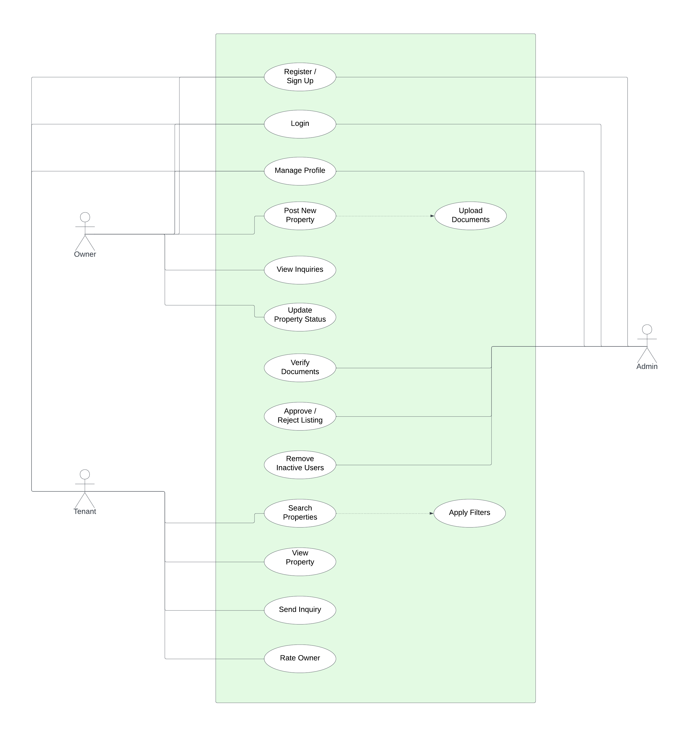
USECASE DIAGRAM

This diagram illustrates the functional interactions between the system and its three primary actors: the Tenant, the Property Owner, and the System Admin. It visualizes the scope of the Home Rental & PG Finder application within the system boundary (the green box).
- Actors & Roles:
  - Tenant: Can search for properties, view details, send inquiries, and rate owners. Their search functionality extends to "Apply Filters," allowing for refined searches based on preferences.
  - Property Owner: Responsible for managing listings. Their "Post New Property" use case includes the mandatory "Upload Documents" step, ensuring the verification process is initiated immediately.
  - System Admin: Acts as the gatekeeper. They verify the documents uploaded by owners and have the authority to "Approve/Reject Listings" and "Remove Inactive Users" to maintain platform integrity.
- Common Functionalities: All three actors interact with the system's core security features: Registration, Login, and Profile Management.

